Lab 3 Mohammad Danusaputro
Section 1

1.Yes, as a programmer you have to be worried, and precision.
2.0.1
3. (1+2)*3 = 9, 1+2*3 = 7
4. % means remainder operation, 12%2 = 0
5. NaN stands for not a number,
6. I’m testing the code in FireFox Browser. I can see console window in Firefox by pressing Ctrl+Shift+K or by menu Tools → Web Developer → Web Console.
My JavaScript code is

console.log("Hello World \\!!!");

I use double slash to print single slash. Because single slash is used in escaping characters.
Here is the screenshot of my console window
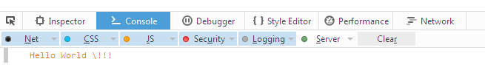

7. Unary Operator
8.Yes, because lower case is always higher than upper case
9. 0 & lower case is lower than upper case
10. symbols are called operator for example * and +, it is use for between two values will apply it to those values and produce a new value. console.log(false || true) means operator denotes logical or. It produces true if either of the values given to its is true. console.log(false || true) – true
11. Since “1>2” expression is false, it chooses second option and prints 2 in console.
Changing the greater sign to less than sign prints the opposite value.

console.log((1<2)?1:2);
12.
console.log("7" + 1); | Since “7” is string type, it tries to concatenate first, since concatenation succeeds it prints 71
console.log("7"*1); | Here string types “7” is converted to numeric 7 and multiplied by 1, so it prints 7
console.log("three"*3); | Here string “three” cannot be converted to any value so value will be “undefined” and results will be Not a Number i.e. NaN
console.log("three"+ "two"); | Here it just concatenates two strings and prints “threetwo”
console.log(false==0); | False and Zero are equal by value, so it prints “true”
console.log(false===0) | Even though False and Zero equal by value, their types differ, so they are not equal Exactly. Therefore, it prints “false”

Here is the screenshot of the results

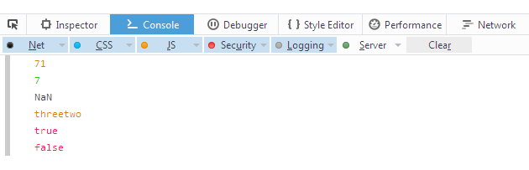

Here is the full code:
<!doctype html>
<html lang="en">
<head>
<meta charset="utf-8">
<title>ACTIVITY 1</title>
<meta name="description" content="JavaScript Course">

<!--[if lt IE 9]>
<script src="https://cdnjs.cloudflare.com/ajax/libs/html5shiv/3.7.3/html5shiv.js"></script>
<![endif]-->
</head>

<body>
<script>
console.log("Hello World \\!!!");
console.log((1>2)?1:2);
console.log((1<2)?1:2);
console.log("7" + 1);
console.log("7"*1);
console.log("three"*3);
console.log("three"+ "two");
console.log(false==0);
console.log(false===0)
</script>
</body>
</html>

Section 2
The console output will be “system. Out. Print/3ii+/input stream reader”. The buffer reader for the input console will be in= new buffer reader (new stream and system in). The console output is determined by the main stream input and influences the output.
The shortcut for the operation is “string text stream reader = in. stream reader/x=2, *33/;” or the out stream. Additionally, the shortcut could also be described as x**33/2; input mainstream. The shortcut is described by the mainstream code such as the log (I’m not happy) in the console code.
In the storage of the string variable, “I’m not happy”, I would use double quotes. The double quotes are important in the decryption of the JavaScript data. Additionally, the single quotes limit the scope and expansion of the console variable. In the use of the double-quote, the decryption would be lessened.

Section 3
The placing of a comment in JavaScript includes a multiple line C style. The style includes the elements / * and * / as the comments in the script. For example, /* comment*/. Depending on the number of comments that one wants to make a JavaScript, the number of lines can be made as many as possible to differentiate the comments from the rest of the script (Tillmann, De Halleux, Xie & Bishop, 2014). There are several ways of making a comment in javascript through the alteration of the /* and */ lines.
The reasons behind using the semicolons in JavaScript include debugging the subtle elements if differentiated bugs. Additionally, the semicolons make it clearer in the situations that require later coding aspects. A statement in JavaScript is an expression of codes that alter the stream meaning through either value addition or deduction. A JavaScript code block is a statement expressed in other languages as an expression of zero or more statements that is always not limited by the brackets it depicts.
Section 4
The response property of the comments includes a condensed stream. The coded streams under the /* and */ depict the response console. The other properties include the facilitation codes such as the curly brackets and the dominating IP code formation encrypts. I can use the response property to call the API chosen in the project. The use of the property makes the applications of the AWS response objects. The differentiation of the data property and the error property facilitates the access of data that is given as the response feedback in the project object (Kumari, Singh & Saxena, 2015). The retrieval of the serialized data is made possible through the formation of the data returns from and to the project in API. In addition, the response property also enables the conclusive elements in the retrieval of data.

